Portfolio 3 – Transactions and Concurrency
TRANSACTIONS
Transactions in databases treat a group of operations as a single unit of work; i.e., it entirely executes all parts of the operation or don’t execute it at all.
CONCURRENCY
Concurrency refers to the simultaneous access and interaction with a database by multiple clients.
ISOLATION
Isolation ensures that concurrent database transactions do not interfere with one another, maintaining data accuracy and consistency during simultaneous operations.
Task (to show transaction): Insert 2 new records for new appointments with these details:
- patient_id:12, doctor_id:3, appointment:2026-12-28, appointment time: 12:00:00, status: scheduled
- patient_id:1, doctor_id:8, appointment:2026-12-27, appointment time: 10:00:00, status: Completed
Table before new rows inserted
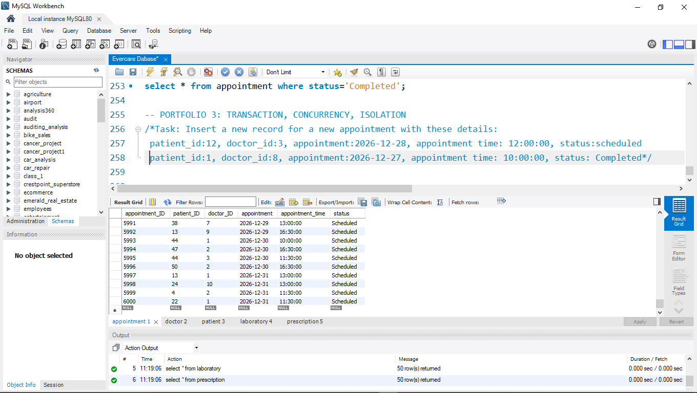

Table after inserting records
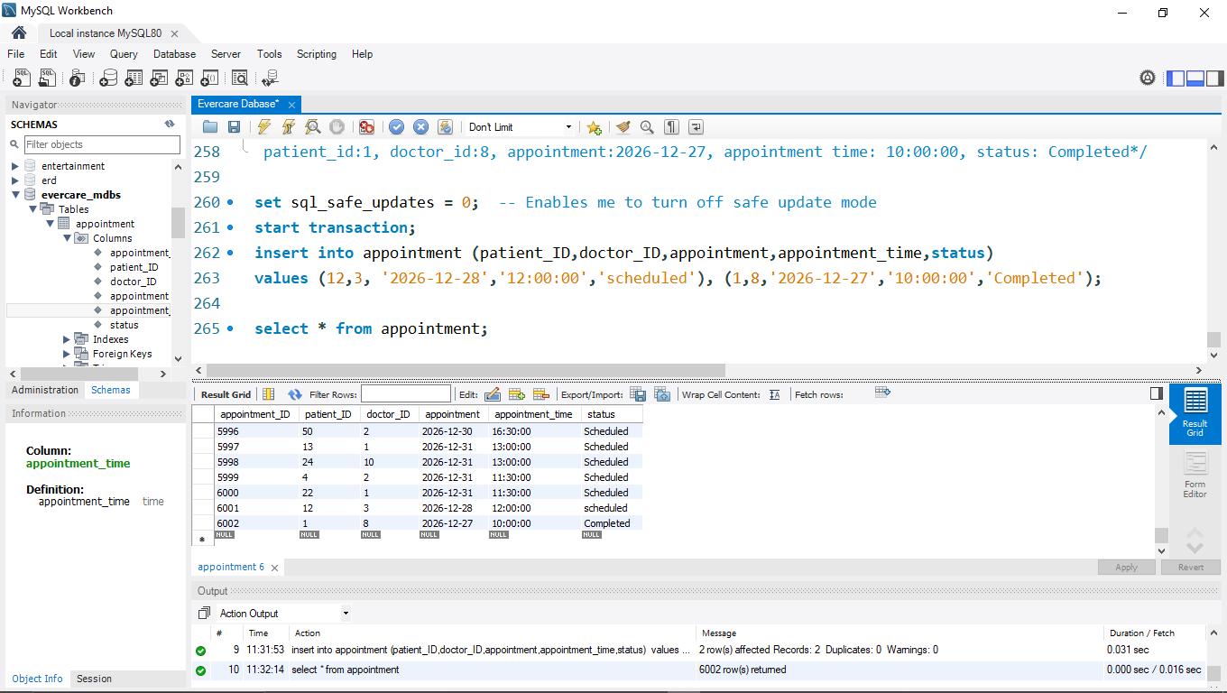
Table after Rollback
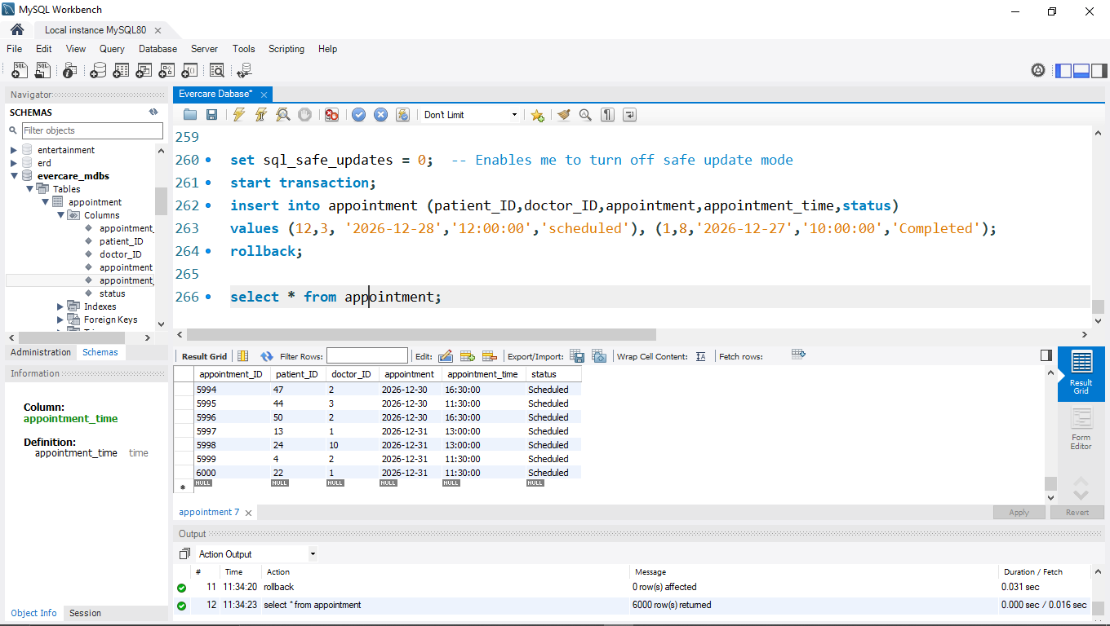

Table after committing
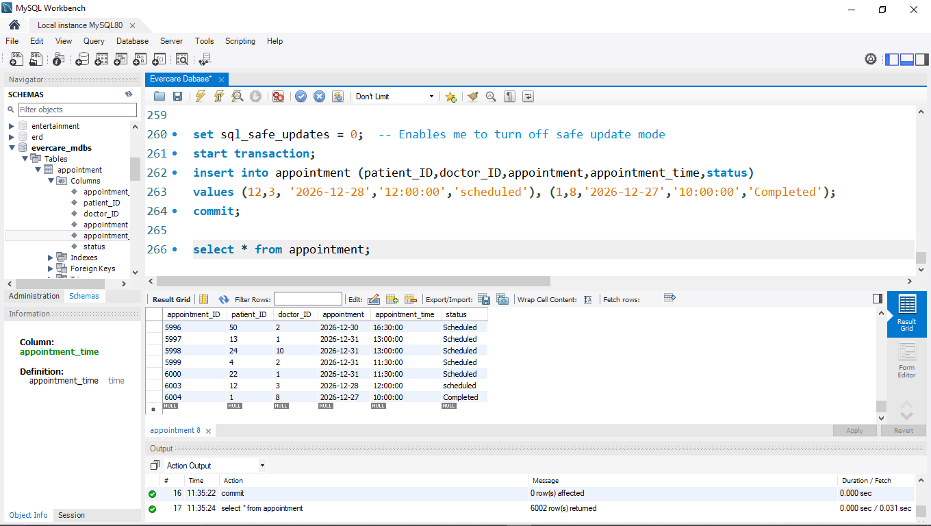

To show isolation
For this, we will use two database connection instances that will be connected to the same database: the Evercare database. We will update the specialization for doctor id: 1 (Dr. Elizabeth Carter), and then try to preview her information on a new connection instance.
Task: Update the specialization for Dr. Elizabeth Carter from Cardiology to Pediatrics
User 1: Changes specialization from Cardiology to Pediatrics for doctor ID 1
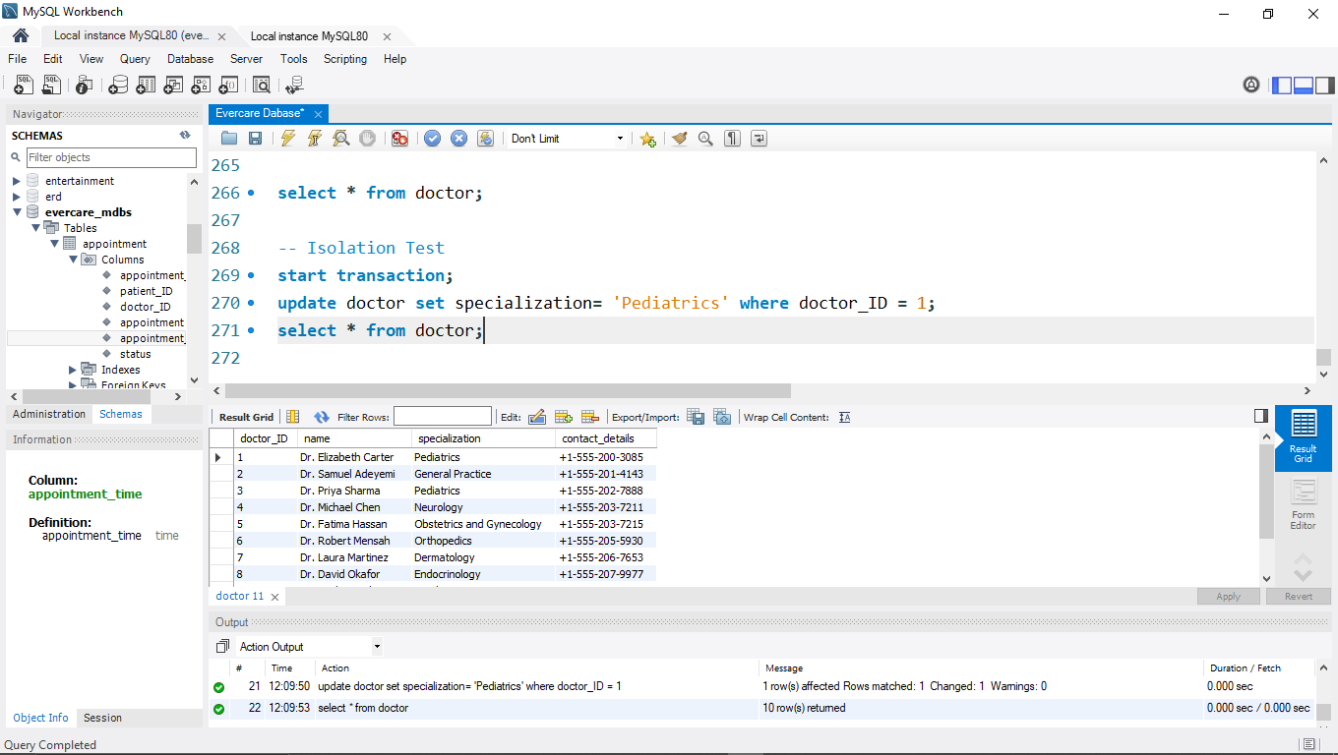

User 2: Creates a new connection to the database
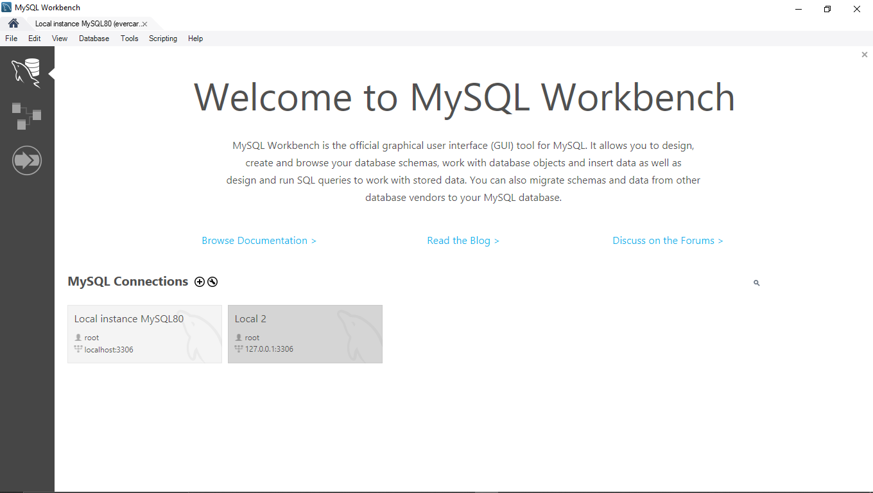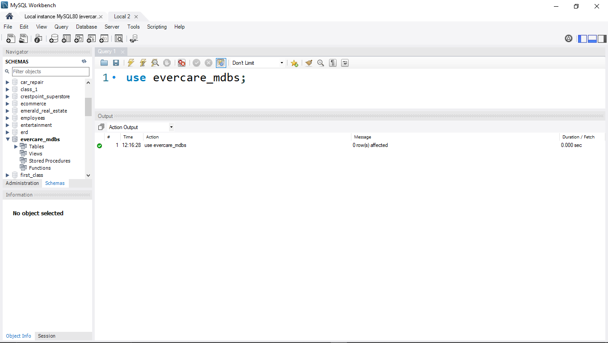

For user 2, Doctor with id 1 still has Cardiology as her specialization because the transaction hasn’t been committed from user 1
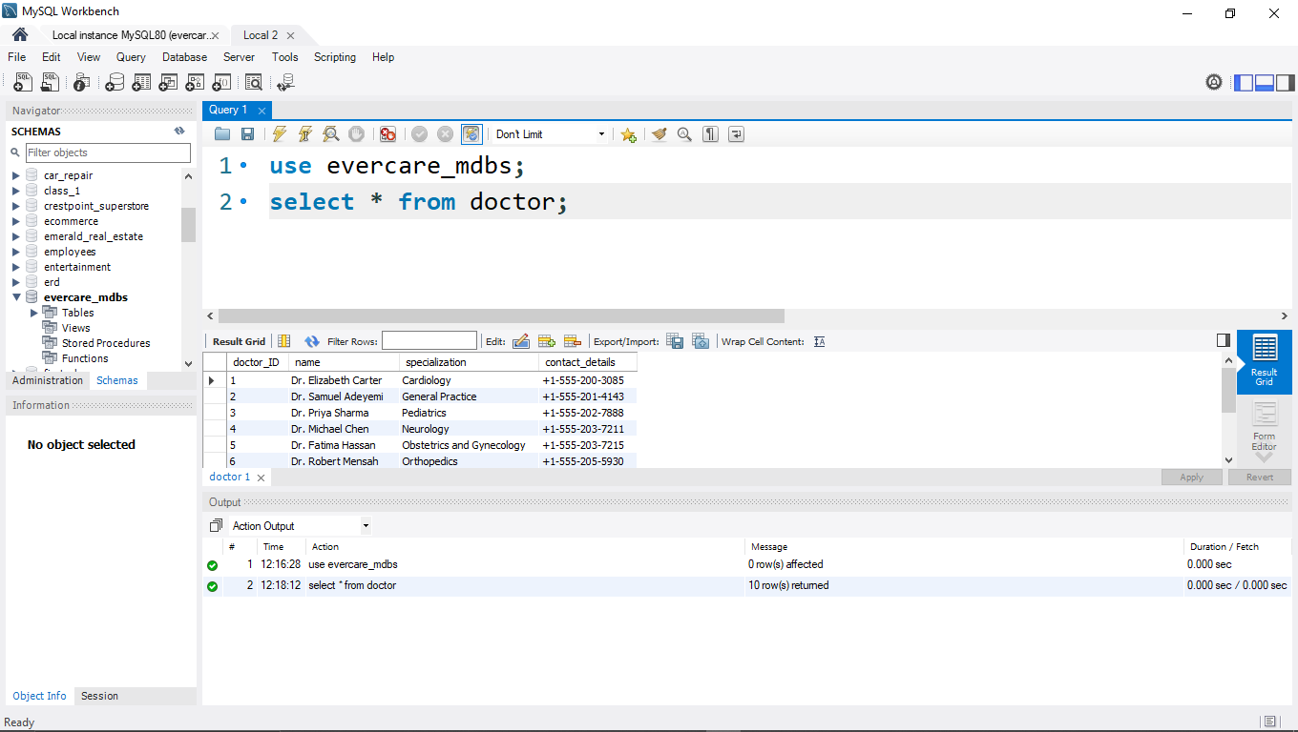

Now, after user 1 commits the changes, user 2 can see the updated data. This satisfies the isolation condition of transactions.
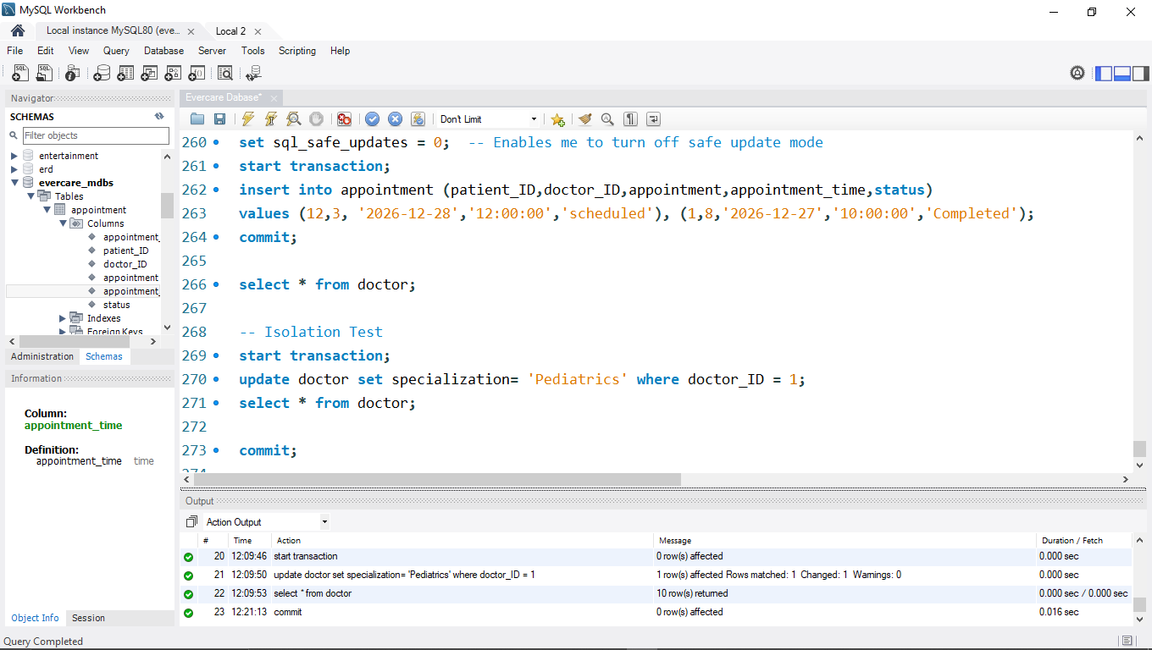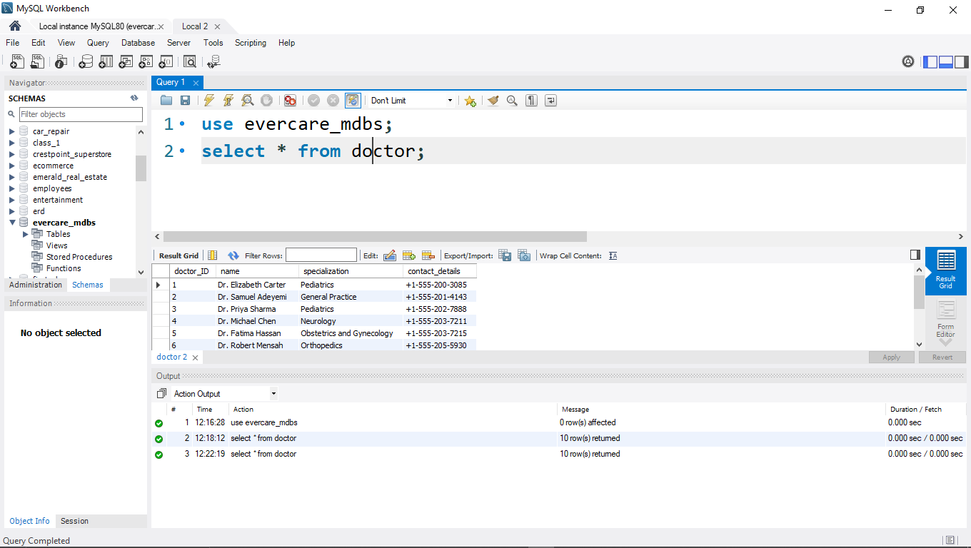

To show Concurrency
To show this, user 1 updates the appointment time for appointment ID 6003 to 11:00:00, while user 2 tries to update its status to completed
Original information for appointment ID 6003
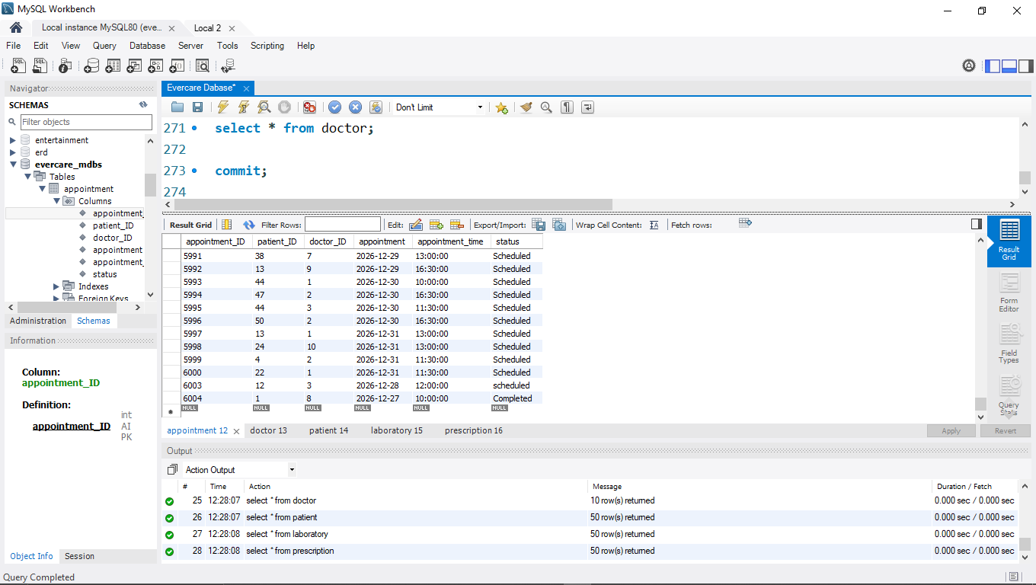

Time changes from 12:00:00 to 11:00:00 for user 1
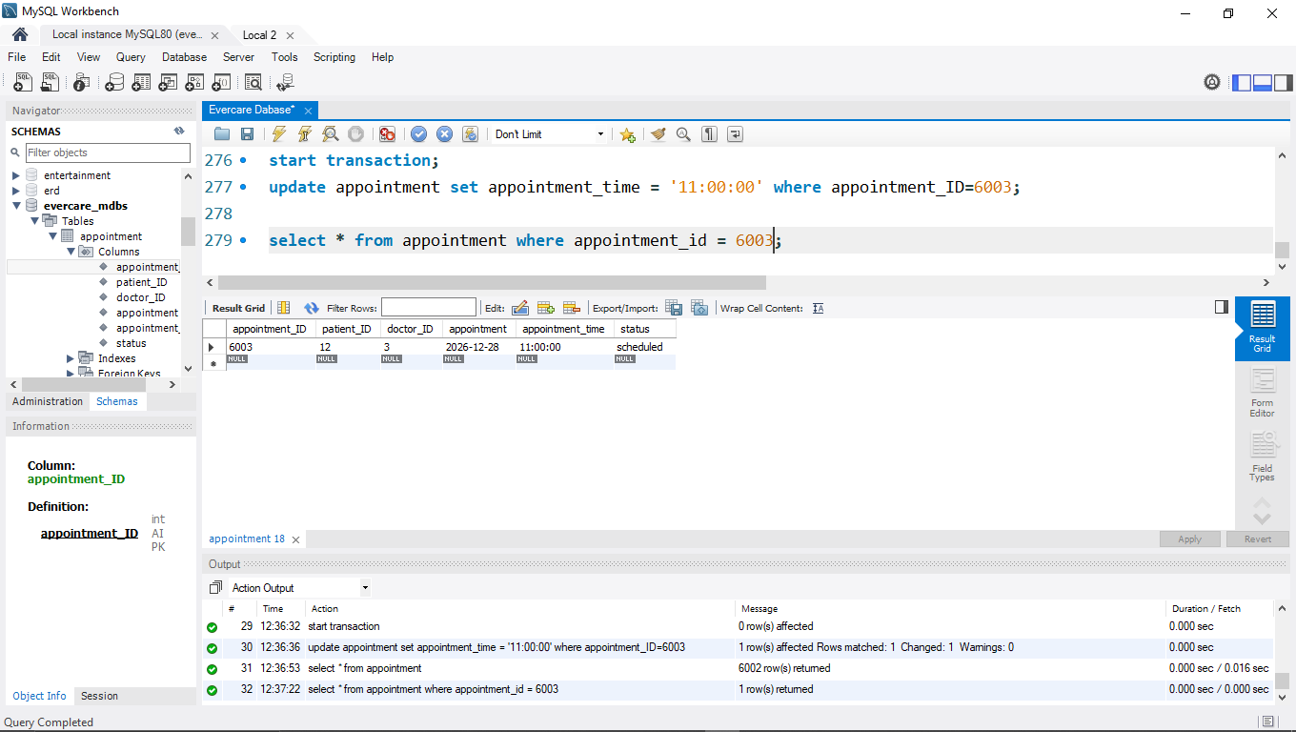
Now, without user 1 committing the transaction, user 2 tries to update the same record for id 6003
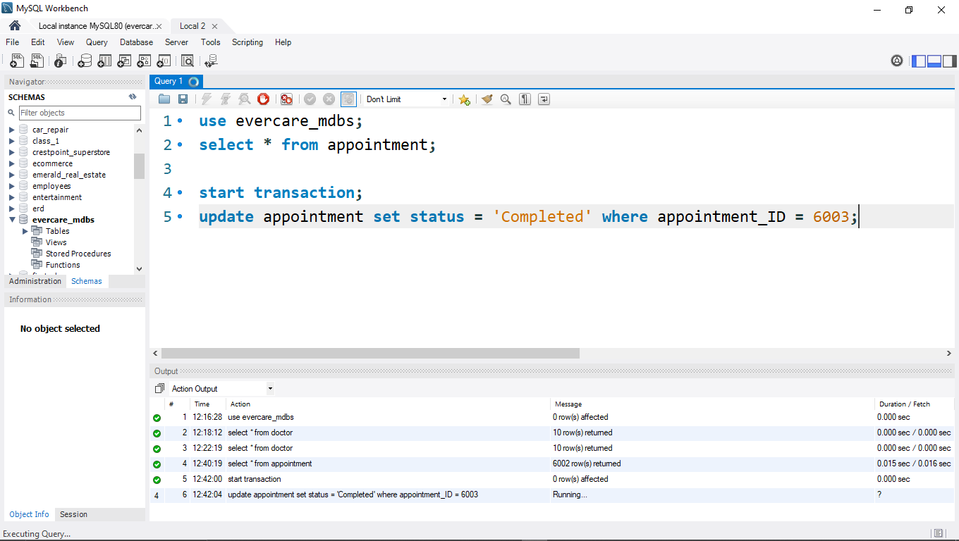
The update keeps on running without being executed, since there is a lock on that record as a result of User 1 not committing or rolling back his transaction.
After User 1 commits his change, User 2 is now successfully able to update the record.
